**Experiment No. 7 -To implement fuzzy control system. Design an automobile or washing machine controller**

**Learning Objective:** Student should be able to Learn to design and implement fuzzy control systems using skfuzzy, focusing on fuzzy logic, membership functions, and practical applications.

**Tools:** Python 3 language and Jupyter Notebook

**Theory:**

The tipping problem demonstrates how fuzzy logic can generate complex behavior from a simple set of expert rules. In this example, the goal is to model how you might decide on a tip based on the quality of service and food, each rated between 0 and 10, and the tip, which ranges from 0% to 25%.

**Inputs (Antecedents)**

1. **Service Quality**: Rated on a scale of 0-10, with fuzzy sets "poor," "acceptable," and "amazing."
2. **Food Quality**: Rated on a scale of 0-10, with fuzzy sets "bad," "decent," and "great."

**Outputs (Consequents)**

* **Tip Percentage**: Rated on a scale of 0% to 25%, with fuzzy sets "low," "medium," and "high."

**Fuzzy Rules:**

* IF the service or food quality is good, THEN the tip will be high.
* IF the service is average, THEN the tip will be medium.
* IF both the service and food quality are poor, THEN the tip will be low.

**Code:**

1.Importing all Libraries and Creating all Functions:

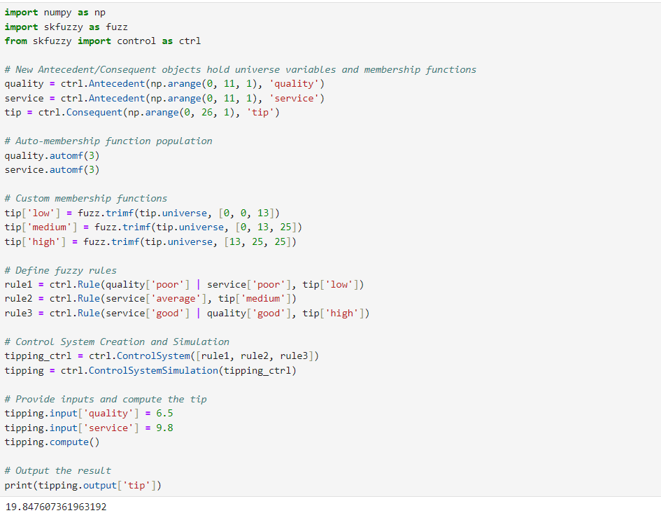

2.To Visualize Using Matplotlib:

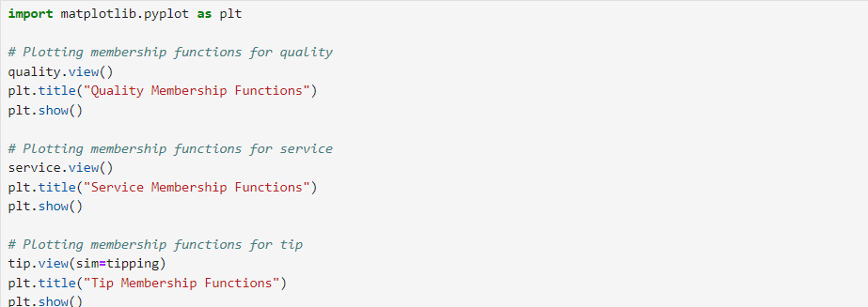

**Output:**

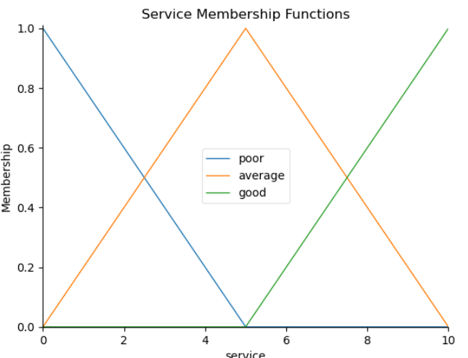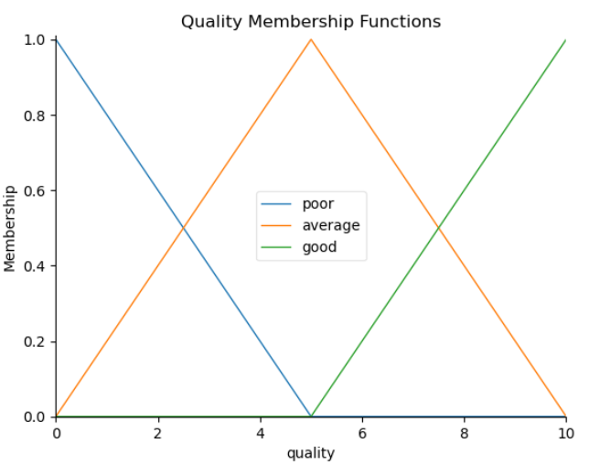

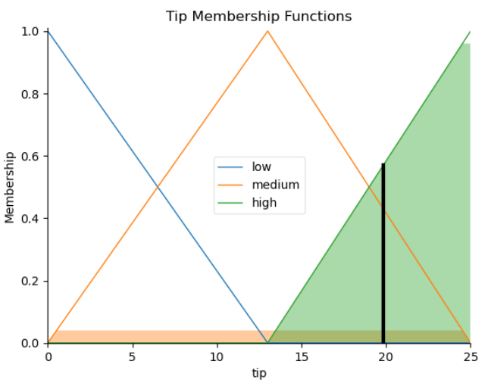

**Conclusion:**

|  |  |  |  |  |
| --- | --- | --- | --- | --- |
| **Correction** | **Formative** | **Timely** | **Attendance /** |  |
| **Parameters** | **Assessment** | **completion of** | **Learning** |
|  | **[40%]** | **Practical [ 40%]** | **Attitude** |
|  |  |  | **[20%]** |
| **Marks** |  |  |  |
| **Obtained** |

___________________________________________________________________________________________________________________________________________________________________________________________________________________________________________________________________________

**_________________________________________________________________________________________**

For Faculty Use: